ZKteco Access Control Distributer in Dubai

Dubai, a [ZKteco Distributor Dubai](https://www.zkteco-dubai.com/) global city, is increasingly relying on cutting-edge technology to ensure its security and efficiency. Within this context, ZKTeco has emerged as a trusted provider in access control solutions, offering a comprehensive range of systems that cater to diverse needs. From fingerprint recognition to facial recognition, ZKTeco's innovative technology provides robust security for businesses, organizations and private properties alike.

Leveraging its expertise in biometrics and smart card systems, ZKTeco enables secure access to sensitive areas. Their solutions are renowned for their accuracy, ensuring only authorized individuals gain entry. Furthermore, ZKTeco's access control systems offer detailed logs, providing valuable data for security analysis and risk mitigation.

* Their commitment to innovation is evident in its continuous development of new technologies, keeping pace with the ever-evolving security landscape.
* Deploying ZKTeco access control solutions can significantly enhance the protection of your assets and personnel.
* With a strong presence in Dubai, ZKTeco provides technical support to its clients, ensuring seamless integration and ongoing maintenance.

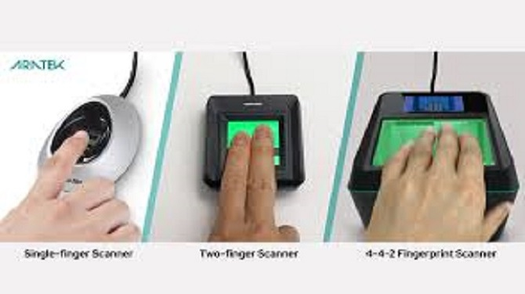

Premier ZKTeco Distributor in UAE: Zkteco Dubai

ZKTeco Dubai stands out as the premier distributor of ZKTeco products in the UAE. With a wide array of cutting-edge access control, time and attendance, and security solutions, they serve diverse needs across various industries. Their experienced team offers exceptional assistance, ensuring seamless implementation and prompt after-sales maintenance. ZKTeco Dubai is committed to providing innovative and budget-friendly solutions, solidifying their position as a trusted partner for businesses seeking top-tier security and access control technology.

Achieve Your Security with ZKTeco Dubai

In today's dynamic environment, safeguarding your assets and personnel is paramount. Collaborating with ZKTeco Dubai, a leading provider of cutting-edge security solutions, empowers you to achieve unparalleled protection. Our robust portfolio encompasses access control systems, biometric identification, time attendance solutions, and video surveillance, all designed to meet the diverse needs of your organization. With ZKTeco Dubai as your trusted partner, you can securely navigate the complexities of modern security challenges.

* Leverage industry-leading technology.
* Gain expert support throughout your security journey.
* Strengthen your overall security posture with integrated solutions.

Enhance Your Business Security with ZKteco - Dubai's Leading Provider

In today's dynamic landscape, safeguarding your enterprise is paramount. Endless Data, a renowned name in security solutions, provides a comprehensive suite of cutting-edge technology to fortify your assets and personnel. From access control systems to biometric authentication, ZKteco's innovative offerings empower businesses across Dubai to minimize risks and provide a secure environment.

ZKteco's unwavering focus to quality and customer satisfaction has earned them the trust of countless clients in Dubai. Their team of experts provides customized solutions to meet the unique demands of each business, providing a seamless and secure experience.

* Benefit from ZKteco's expertise to strengthen your security posture.
* Receive a dependable and cutting-edge security solution.
* Protect your assets, personnel, and reputation with ZKteco.

ZKteco Products and Services: Your One-Stop Shop in Dubai

Looking for a trusted partner to provide you with top-notch security solutions in Dubai? Look no further than Endless Data! As a leading provider of cutting-edge access control, time attendance, and fingerprint systems, ZKteco offers a extensive range of products and services to meet your individual needs.

From state-of-the-art hardware to user-friendly platforms, ZKteco's offerings are designed to streamline your operations while ensuring the highest level of security. Their team of experienced professionals is dedicated to providing you with top-tier customer service and support throughout your process.

Whether you're a small business, ZKteco has the perfect solution for you. Discover their wide selection of products and services today and gain a world of possibilities for your business in Dubai.

Premium ZKteco Distribution and Support in Dubai

Partner with one of the top distributor of ZKteco access control in Dubai. We offer a comprehensive selection of ZKteco products, ensuring reliable performance and advanced technology. Our team of experienced technicians provides outstanding support, guiding you every step of the way.

From implementation to troubleshooting, we're here to enhance your security solutions.

* Reach out to us today to learn more about our ZKteco services.
* Our priority is to provide exceptional service and support.